Project Tugas7

PIC : Izam

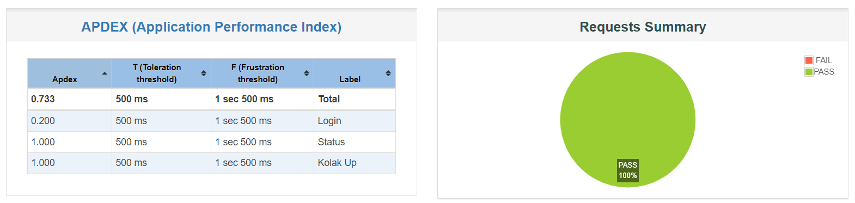

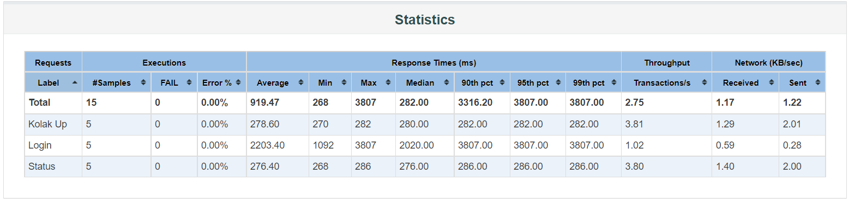

Average response time is around **919.47**ms for Kolak Project

Meanwhile, average vs 99% percentile for each end point is listed below

Error Rate is 0.00%

Login is 2203.40ms vs 2020.00ms

Status is 276.40ms vs 276.00ms

CPU usage

CPU usage vs RPS/throughput.

When we got 3.81s trx/s we got 40% CPU utilization

When we got 1.02s trx/s we got 20% CPU utilization

When we got 3.80s trx/s we got 39% CPU utilization

This is means that our application can handle 9.900 users per hour maximum